**Program Structures & Algorithms**

**Spring 2022**

**Assignment No. 4**

Name: Xinlin Ying

(NUID): 001535622

* **Task**

Implement a parallel sorting algorithm such that each partition of the array is sorted in parallel. You will consider two different schemes for deciding whether to sort in parallel.

1. A cutoff (defaults to, say, 1000) which you will update according to the first argument in the command line when running. It's your job to experiment and come up with a good value for this cutoff. If there are fewer elements to sort than the cutoff, then you should use the system sort instead.
2. Recursion depth or the number of available threads. Using this determination, you might decide on an ideal number (*t*) of separate threads (stick to powers of 2) and arrange for that number of partitions to be parallelized (by preventing recursion after the depth of *lg t* is reached).
3. An appropriate combination of these.

Shows the results of your experiments and draws a conclusion (or more) about the efficacy of this method of parallelizing sort. Your experiments should involve sorting arrays of sufficient size for the parallel sort to make a difference. You should run with many different array sizes (they must be sufficiently large to make parallel sorting worthwhile, obviously) and different cutoff schemes.

* **Output screenshot**

Main.java and ParSort.java

Run the Main.java to get the time for a fixed length array. The cutoff is from 510000 to 1000000 and threads number is 2 to 12.

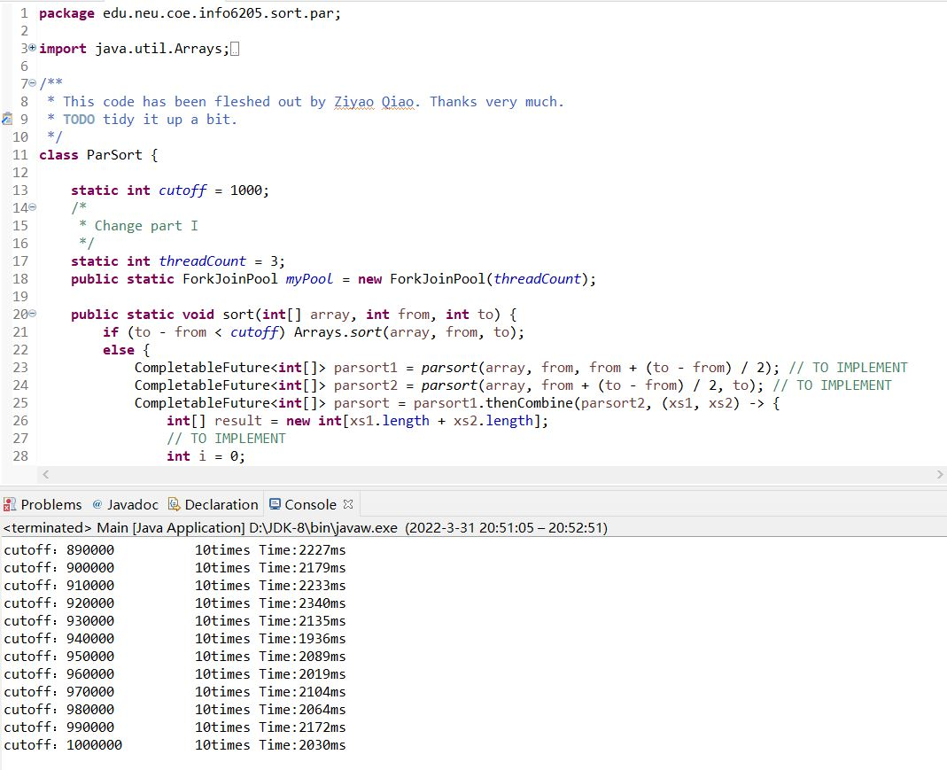

* **Relationship** **Conclusion**
  + **Relationship**

Analyzing the graph we can find that:

* sorting time vs array size:

As the array length increases, the sorting time increases in proportion to the array length.

* sorting time vs threads

For each fixed-length array, the sorting time decreases as the number of threads increases, but when the number of threads increases to a certain threshold, the sorting time optimization is not significant. For example, in the case of a 1M array, when the number of threads reaches 8, the sorting time does not decrease significantly, even though the number of threads is increasing.

* sorting time vs cutoff

For cutoff, there is a big optimization between 510000 and 610000 but after 510000 there is no big change. It is more obvious when the array length is smaller, for example, for a 1M length array, the sorting time of 510000 cutoff is twice as long as 610000. But for 2M and 4M, it is only about 20% lower.

* + **Conclusion**

A good strategy of cutoff and number of threads seems to be 510000 length as cutoff and 8 threads. A really large number of cutoff won’t make much of a difference because other costs will compensate for the parallel sorting and the number of threads doesn’t make difference after a point(generally around 8-10) as we can see from the graph and data sheet.

* **Evidence / Graph**

Line graph between sort time and cutoff

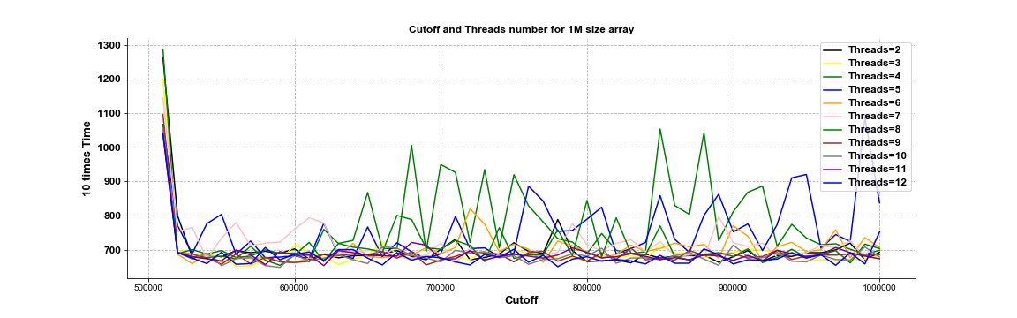

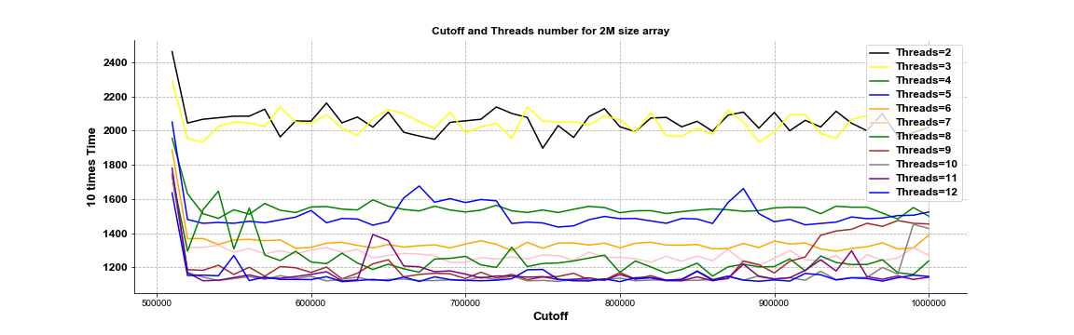

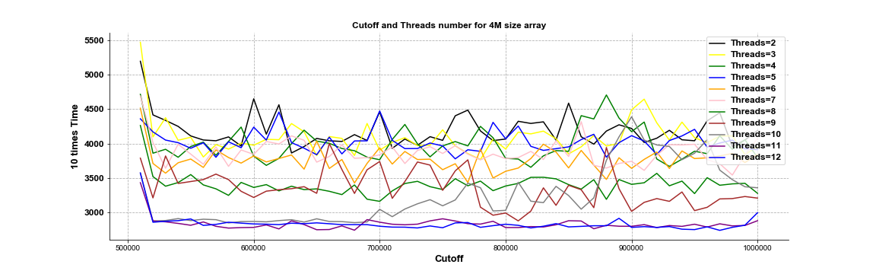Data Sheet

**10 times Time under specific Cutoff and Threads number for 1M size array**

|  |  |  |  |  |  |  |  |  |  |  |  |
| --- | --- | --- | --- | --- | --- | --- | --- | --- | --- | --- | --- |
| **Thread**  **Cuttoff** | **2** | **3** | **4** | **5** | **6** | **7** | **8** | **9** | **10** | **11** | **12** |
| **510000** | **1262** | **1198** | **1287** | **1065** | **1052** | **1144** | **1066** | **1095** | **1057** | **1037** | **1040** |
| **610000** | 672 | 693 | 664 | 673 | 675 | 793 | 721 | 666 | 666 | 684 | 693 |
| **710000** | 730 | 679 | 926 | 797 | 706 | 660 | 727 | 680 | 698 | 673 | 664 |
| **810000** | 667 | 682 | 747 | 824 | 674 | 697 | 679 | 691 | 704 | 676 | 666 |
| **910000** | 697 | 701 | 868 | 775 | 739 | 709 | 702 | 675 | 679 | 683 | 670 |
| **1000000** | 692 | 682 | 698 | 837 | 706 | 745 | 745 | 685 | 678 | 673 | 751 |

**10 times Time under specific Cutoff and Threads number for 2M size array**

|  |  |  |  |  |  |  |  |  |  |  |  |
| --- | --- | --- | --- | --- | --- | --- | --- | --- | --- | --- | --- |
| **Thread**  **Cuttoff** | **2** | **3** | **4** | **5** | **6** | **7** | **8** | **9** | **10** | **11** | **12** |
| **510000** | **2461** | **2288** | **1955** | **2050** | **1887** | **1697** | **1739** | **1743** | **1745** | **1781** | **1636** |
| **610000** | 2161 | 2092 | 1556 | 1461 | 1342 | 1316 | 1222 | 1202 | 1121 | 1175 | 1146 |
| **710000** | 2066 | 2022 | 1535 | 1597 | 1356 | 1258 | 1215 | 1172 | 1145 | 1138 | 1122 |
| **810000** | 1994 | 1989 | 1531 | 1486 | 1341 | 1251 | 1238 | 1132 | 1122 | 1132 | 1140 |
| **910000** | 1999 | 2091 | 1552 | 1481 | 1337 | 1229 | 1250 | 1236 | 1140 | 1140 | 1120 |
| **1000000** | 2020 | 2051 | 1500 | 1524 | 1389 | 1271 | 1238 | 1454 | 1428 | 1143 | 1147 |

**10 times Time under specific Cutoff and Threads number for 4M size array**

|  |  |  |  |  |  |  |  |  |  |  |  |
| --- | --- | --- | --- | --- | --- | --- | --- | --- | --- | --- | --- |
| **Thread**  **Cuttoff** | **2** | **3** | **4** | **5** | **6** | **7** | **8** | **9** | **10** | **11** | **12** |
| **510000** | **5197** | **5473** | **4716** | **4360** | **4515** | **4693** | **4263** | **3788** | **3572** | **3431** | **3572** |
| **610000** | 4137 | 4062 | 3683 | 4051 | 3733 | 4031 | 3403 | 3308 | 2862 | 2817 | 2828 |
| **710000** | 3931 | 4017 | 4060 | 4047 | 3702 | 3952 | 3312 | 3204 | 2937 | 2827 | 2785 |
| **810000** | 4324 | 4166 | 3775 | 4255 | 3644 | 3796 | 3421 | 2876 | 3437 | 2779 | 2811 |
| **910000** | 4016 | 4646 | 4313 | 4038 | 3770 | 3610 | 3430 | 3145 | 4051 | 2821 | 2792 |
| **1000000** | 4191 | 3951 | 3798 | 3912 | 3845 | 4076 | 3277 | 3207 | 3357 | 2878 | 2994 |